User Interface Specification

*The user interface should be specified only for the use cases elaborated in the previous section (“fully dressed” use cases).*

**Preliminary Design**

*For a given use case, show step-by-step how the user enters information and how the results appear on the screen.*

*Use screen mock-ups and describe exactly what fields the user enters and buttons the user presses. Describe navigational paths that the user will follow.*

*In case you are developing a graphics-heavy application, such as a video game, this is one of the most important sections of your report.*

**User Effort Estimation**

*Select several typical usage scenarios and, as you walk through the flow of events, count and report the number of mouse clicks and/or keystrokes that are needed to accomplish the task. What fraction of these goes to user-interface navigation vs. clerical data entry?*

*http://www.ece.rutgers.edu/~marsic/Teaching/SE1/report1-appA.html*

**Sample Report**

**Preliminary Design**

After a series of brainstorming sessions an initial design was sketched out with some ideas as to how the main screen of the App would appear and the functions we would want it to have. We decided upon a simplistic design to ensure the App would be user friendly and also placing aesthetics as a factor of paramount importance. These initial sketches are shown below:

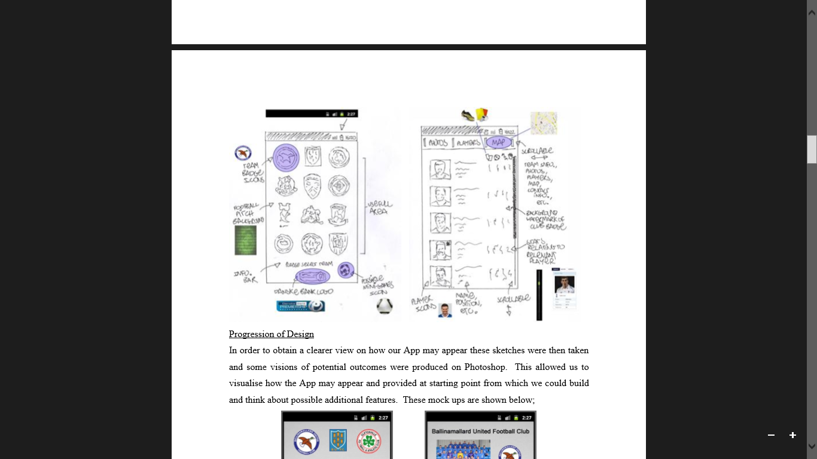

In order to obtain a clearer view on how our App may appear these sketches were then taken and some visions of potential outcomes were produced on Photoshop. This allowed us to visualise how the App may appear and provided at starting point from which we could build and think about possible additional features. These mock ups are shown below:

